**Project Design Phase-II**

**Technology Stack (Architecture & Stack)**

**Technical Architecture:**

The Deliverable includes the architectural diagram as below and the information as per the table1 & table 2

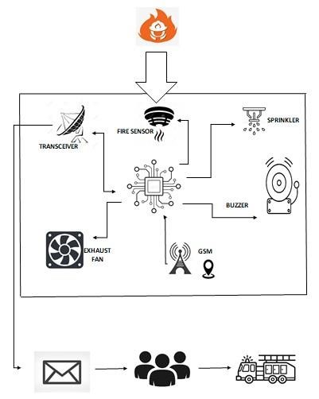

**Table-1 : Components & Technologies:**

|  |  |  |  |
| --- | --- | --- | --- |
| **S.No** | **Component** | **Description** | **Technology** |
| 1. | User Interface | How user interacts with application e.g.  Web UI, Mobile App. | HTML, CSS, JavaScript / Angular JS / React JS etc. |
| 2. | Application Logic-1 | Logic for process in the application | Python |
| 3. | Application Logic-2 | Logic for process in the application | IBM Watson STT service |
| 4. | Application Logic-3 | Logic for process in the application | IBM Watson Assistant |
| 5. | Protocol | Data transmission and reception. | HTTP |
| 6. | Cloud Database | Database Service on Cloud | IBM DB2, IBM Cloudant etc. |
| 7. | File Storage | File storage requirements | IBM Block Storage or  Other Storage Service or Local File system |
| 8. | Internet Of Things | Purpose of IOT Model | Fire detection and prevention. |
| 9. | Infrastructure (Server / Cloud) | Application Deployment on  Local System / Cloud  Local Server Configuration  Cloud Server Configuration | Cloud Foundry, Kubernetes, etc. |

**Table-2: Application Characteristics:**

|  |  |  |  |
| --- | --- | --- | --- |
| **S.No** | **Characteristics** | **Description** | **Technology** |
| 1. | Security Implementations | List all the security / access controls implemented. | IBM Cloud (Authorized people can only access).  Flash Encryption and Secured Boot |
| 2. | Scalable Architecture | Justify the scalability of architecture (3 – tier, Microservices) | Internet Of Things,  Scaling up of IBM Cloud. |
| 3. | Availability | Justify the availability of application. | Available for the authorized people. |
| 4. | Performance | Design consideration for the performance of the system. | In order to send the information at every instant, the setup is connected to the cloud. |